**Europe’s olive oil supply running out after drought – and the odd hailstorm**

Heatwaves around Mediterranean have damaged harvests and forced producers to import from South America

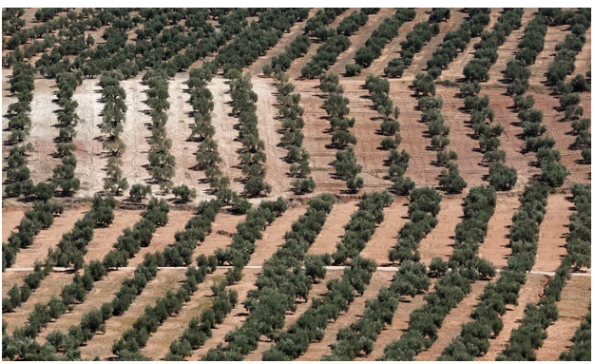

Europe has almost run out of local olive oil supplies and is set for more shortages, after extreme weather damaged harvests for a second year.

The world’s largest producer has said it is having to import supplies from South America to keep up with demand.

“Today it is almost physically impossible to buy olive oil. It is sold out,” Walter Zanre, the chief executive of the UK arm of Filippo Berio, said.

Olive trees have been cultivated around the Mediterranean for thousands of years, with[**Spain**](https://www.theguardian.com/world/spain) alone producing half of the world’s supply of olive oil, but wildfires and soaring summer temperatures mean the future of this ancient industry is looking increasingly uncertain.

Global production is expected to fall to 2.4m tonnes according to the International Olive Council. Extreme weather in other important growing regions including Greece, Italy and Portugal as well as Turkey and Morocco has added to the crisis.

Zanre said the company still had stock to meet its delivery demands but had been forced to import olive oil from Chile to cover the gap before the arrival of this year’s harvest, which